BANG COLLEGE OF BUSINESS

Meeting Minutes of College Council Committee
September 7, 2020
E-voting

Members of College Council Committee:
Dr.Ho Young Lee, Dean of BCB
Dr.Dewan Islam, Associate Dean of Graduate Program
Bibigul Zhakupova, Chair of Accounting and Finance Department
Dr.Nurlan Orazalin, Assistant Professor, Accounting Area
Dr.Vladimir Garkavenko, Associate Professor, Marketing Area
Dr.Alma Sharipova, Assistant Professor, Finance Area
Dr.Uldana Baizyldaeva, Assistant Professor, OMIS Area
Dr.Yuliya Frolova, Associate Professor, Management Area
Dr.Muhammad Arslan, Assistant Professor, Accounting Area
Dr.Jungmin Jang, Assistant Professor, Marketing Area30
Dr.Nadeem Khalid, Associate Dean of EEC

Meeting Secretary:
Aizada Agabayeva, Executive assistant to the Dean of BCB (non-voting)

Voting 11 out of 11 members

Agenda Item. To approve Graduate Checklist of 1 graduate student: 1 – Ex. MBA program

Bang College of Business
Ex.MBA, Executive Master of Business Administration
7M04107
20201426 | Ex.MBA | 7M04107 | Jangabulova | Sholpan

Motion made by Dr.Uldana Baizyldayeva to approve 1 graduate checklist .
Seconded by Dr.Muhammad Arslan
All in favor

Results: All in favor -11. Motion passed

Motion passed:
Dr.Ho Young Lee 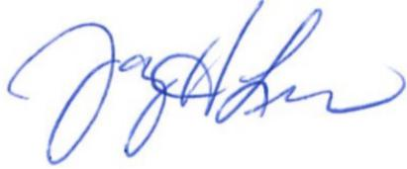
Dr.Dewan Islam _____In favor___________
Dr.Nurlan Orazalin _____In favor___________
Ms.Bibigul Zhakupova _____In favor___________
Dr.Vladimir Garkavenko _____In favor___________
Dr.Alma Sharipova ____In favor____________
Dr. Uldana Baizyldayeva ____In favor____________
Dr.Yuliya Frolova ____In favor____________
Dr.Muhammad Arslan ____In favor____________
Dr.Jungmin Jang ____In favor____________
Dr.Nadeem Khalid ____In favor____________

