Timocracy and Oligarchy in Plato’s Republic

Micah Robert Safsten

Feb 10, 2020·4 min read

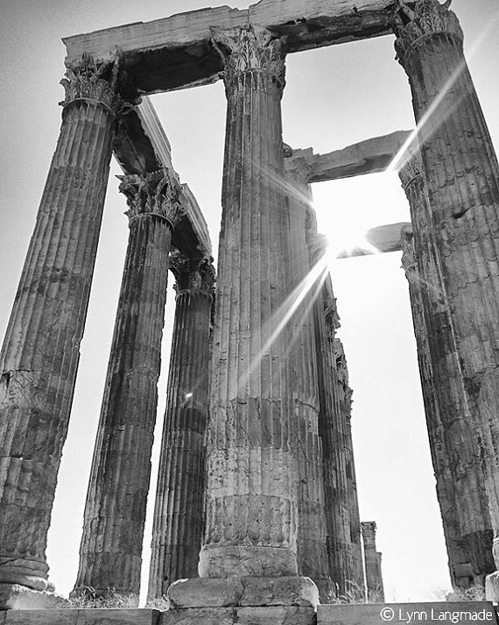
In Plato’s Republic, Socrates describes how regimes degenerate over time and in five identifiable stages, beginning with an aristocracy and ending in tyranny. Socrates presents this degeneration as the result of human imperfection, with each stage sowing the seeds for a transition into the next. It is the transition from the honor loving timocracy into the money loving oligarchy where we see this transition most visibly. Virtuous and wise leaders can not rule forever, and eventually, a regime that values money over honor develops. Socrates describes this particular transition as one from a regime that values money only inasmuch as it brings honor into one that values money for its own sake. It is correlated with the man who begins to value his necessary desires over his own honor. Socrates implicitly suggests that this devolution is inevitable, as higher political regimes are corrupted into lower regimes by the imperfections of man.
The timocratic man, according to Socrates, is exemplified in the man raised by a calculating father and a desirous mother. His father breeds in him a love of wisdom, while his mother breeds the desiring portion of his soul. The love of honor is a compromise between these competing priorities. He spends his days training “the part that loves victory and is spirited; he became a haughty-minded man who loves honor” (550b). The timocratic man is the microcosm of the timocracy itself. It is a regime that corrupts wisdom with desire and ultimately reaches a compromise with honor. In a timocracy, men love money, but only “under cover of darkness” (548a). Having only recently transitioned from the highest regime, the aristocracy, timocracies seek to appear as aristocratic. Timocracies appear aristocratic “In honoring the rulers, and in the abstention of its war-making part from farming and the manual arts and the and the rest of money-making; in its provision for common meals and caring for gymnastic and the exercise of war” (547d). To be perceived as aristocratic is important to the timocrat because he honors the aristocrat, even if he does not live like the aristocrat. In his heart, however, the timocratic man also honors wealth and it is this corruption that becomes his defining characteristic and ultimately what leads to oligarchy.
The timocratic honor of wealth is hidden, because it must be reckoned with a desire to be perceived as wise. Timocracy, as Socrates describes it, is a “certain middle between aristocracy and oligarchy” (547c). The timocracy, then, will be characterized by those who are “stingy with money because they honor it and don’t acquire it openly” (548b). As this timocratic nature blossoms, the tension between honoring wisdom and honoring money reaches a tipping point. It becomes obvious to the timocratic man that honoring virtue and wisdom is no longer compatible with honoring money and wealth. This realization transforms the timocracy into an oligarchy, or a regime that loves money-making. In an oligarchy, the pursuit of money becomes virtuous for its own sake, where it was simply a means to gain honor in the timocracy. Oligarchies prescribe certain levels of wealth that must be attained before one can participate in the political process. “[T]he man whose substance is not up to the level of the fixed assessment shall not participate in the ruling offices” (551b). When this practice is in place in an oligarchy, the transition from an honor loving society to a money loving society is complete.
Socrates has little faith that such a transition is avoidable. The “treasure house full of gold… that each man has” eventually becomes too enticing not to protect in law. When enough timocracts come to honor money above all else, they alter the laws of the country to protect this desire. By contrast, those that still honor wisdom over money have no method by which to encode their desire into law. Money becomes its own good, as only those who have it in sufficient quantities are given the ability to hold office. A timocracy can hold only if it protects those who themselves value wisdom over desire. When it sees honor in both wisdom and desire, it can hold, but this balance is not inevitable. It will fall, and when it does, it will tip toward those who seek to protect their values with the law- the oligarchs.
Preserving a timocracy, then, is like flipping a coin over and over again and getting “heads” every time. Seeing “heads” 100 times in a row does not ensure that the 101st flip of the coin will also be “heads.” Likewise, a regime experiencing 100 generations of timocracy does not ensure that the 101st generation will not devolve into oligarchy. Money is too enticing, the necessary desires of man too strong, to be staved off forever.
Socrates saw the devolution of timocracy to oligarchy as an inevitable realization by the timocrat that he was balancing two competing priorities: wisdom and desire. While it was possible to delay this transition into oligarchy, the draw of money would always win out eventually. Indeed, the timocratic man is always operating on a flawed assumption, that one could place honor before wisdom. If follows, then, that the timocratic man and the timocracy itself would eventually choose the flawed priority of desire.
Works Cited
Plato. The Republic of Plato. Translated by Allan Bloom. United States of America: Basic Books, 1991.

