Preparation to the midterm exam #1

Problem



Answer:



Problem

Fit an educational attainment function, regressing *S* on *ASVABC*, *SM*, *SF*, and *ASVAB05*. Perform an *F* test of the explanatory power of *ASVAB06*, using the results of this regression and that in Exercise 3.19. Verify that it leads to the same conclusion as a two-sided *t* test.

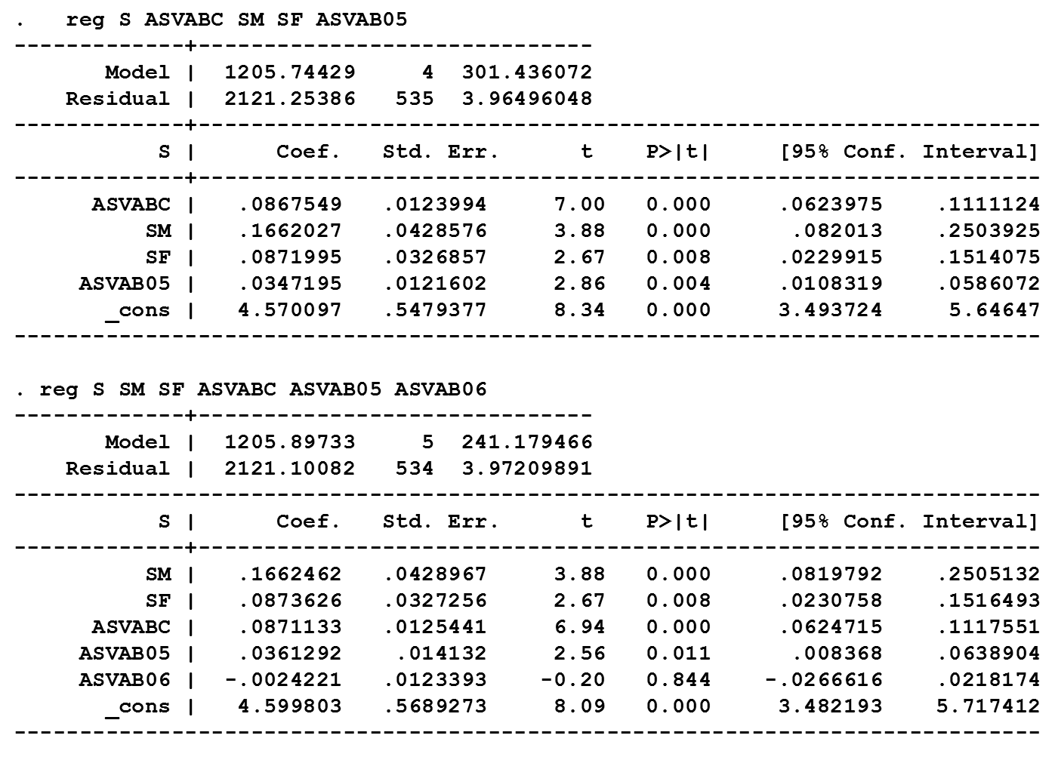

Answer



