**Preparation to the midterm #1.**

Find a total differential of the following functions.

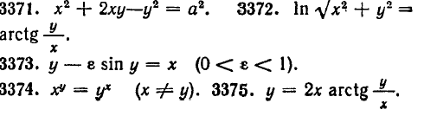

Find derivatives of implicit functions.

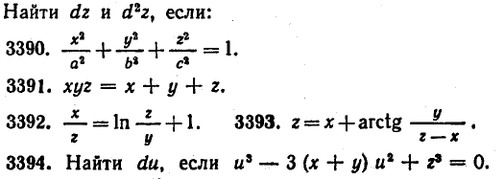



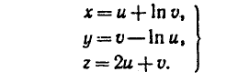

**Problem #4**

Use a Jacobian determinant to test the existence of functional dependence between the paired functions.



**Problem#5**

Calculate a total differential ( dU) of the following function:



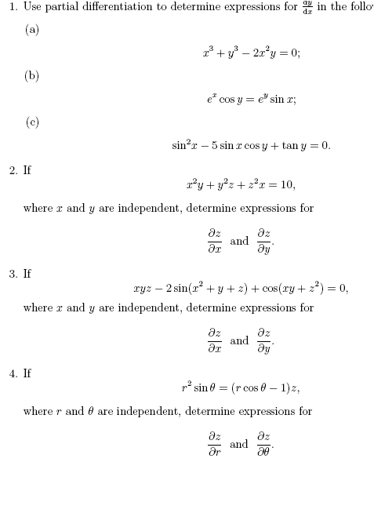

**Problem 6:** The demand function of a commodity is given by; , where q is the quantity demanded and p is the price of a commodity. Find the price elasticity of demand at the point on the demand curve where p = Tk 1.

**Problem 7:** Suppose a demand function of a commodity is given by;  where q is the quantity demanded and p is the price of a commodity. Find the price elasticity of demand at the point on the demand curve where p = Tk 4. What is the price elasticity of demand at the point when p = Tk 5? What is the Arc elasticity between these two points?

**Problem 8:** Suppose the price of tea rises from 50 Taka to 100 taka per 100 grams, as a results the quantity demanded of coffee is given by; , where  is the quantity demanded of coffee and  is the price per hundred-gram tea. Find the cross elasticity of demand of coffee.

**Problem 9 :** The average cost function (AC) for a commodity is given by;  in terms of output level q. Find the value of q for increasing and decreasing level of AC. Also find the total cost and marginal cost.

**Problem 10 :** The total cost function is given by; . Find (i) Average cost (AC), (ii) Marginal cost (MC), (iii) Slope of AC .

**Problem 11 :** Let the cost function is given by; , where C is the cost and x is the level of output. Find the average cost (ii) the marginal cost and (iii) the point at which MC is equal to AC

**Problem 12.** Find the marginal cost function and average cost function.



|  |  |
| --- | --- |
| **Function** | **Derivative** |
| *sin*x | *cos*x |
| *cos*x | -*sin*x |
| *sin*2x | 2∙*sin*x∙*cos*x = *sin*2x |
| *cos*2x | -2∙*sin*x∙*cos*x = - *sin*2x |
| *tan*x = *sec*2x | 1/(*cos*2x) = 1+*tan*2x |
| *cot*x = -*csc*2x | -1/(*sin*2x) = -1-*cot*2x |
| *sec*x | *sec*x∙*tan*x |
| *csc*x | -*csc*x∙*cot*x |
| *arcsin*x = *sin*-1x | 1/√(1-x2) |
| *arccos*x = *cos*-1x | -1/√(1-x2) |
| *arctan*x = *tan*-1x | 1/(1+x2) |
| *arccot*x = *cot*-1x | -1/(1+x2) |
| *arcsec*x = *sec*-1x | 1/(|x|∙√(x2-1)) |
| *arccsc*x = *csc*-1x | -1/(|x|∙√(x2-1)) |